**AWS CLOUD COMPUTING**

**Practical no.7**

**AIM:** *Demonstrate Usage of IAM on AWS console****.***

## **Step 1.** Navigate to the IAM Console.

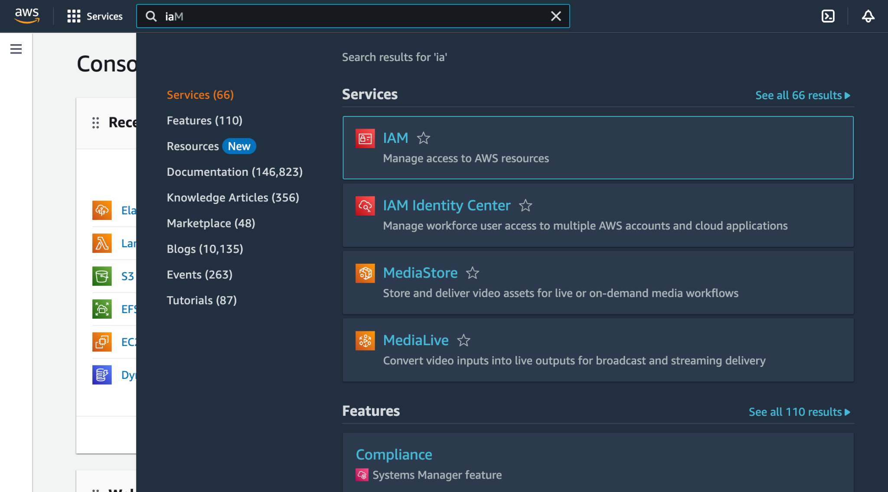

## **Step 2.** Click on create user and add a specific username. Also tick the checkbox which says”Provide user access to the AWS Management Console - *optional”* and then click *next.*

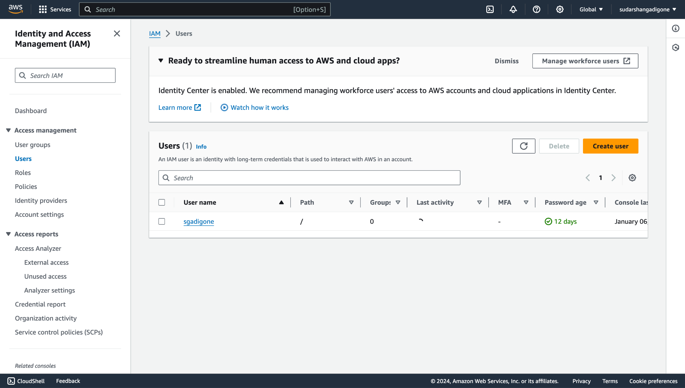

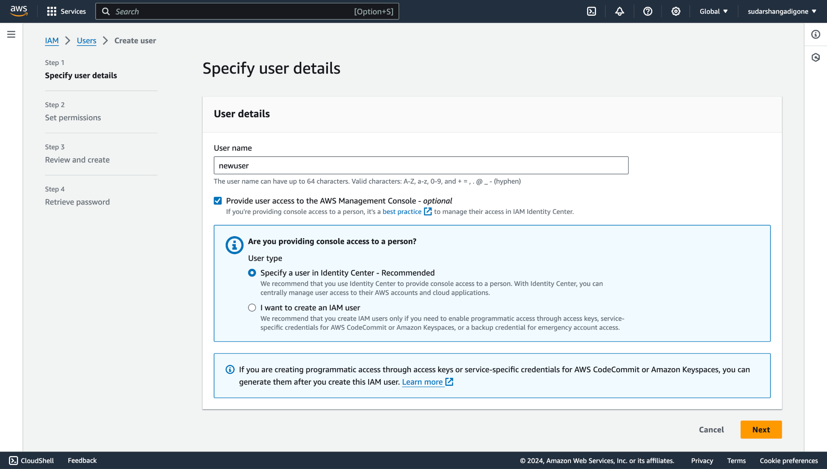

**Step 3.** Now select i want to create an IAM user and add a custom password then click next.

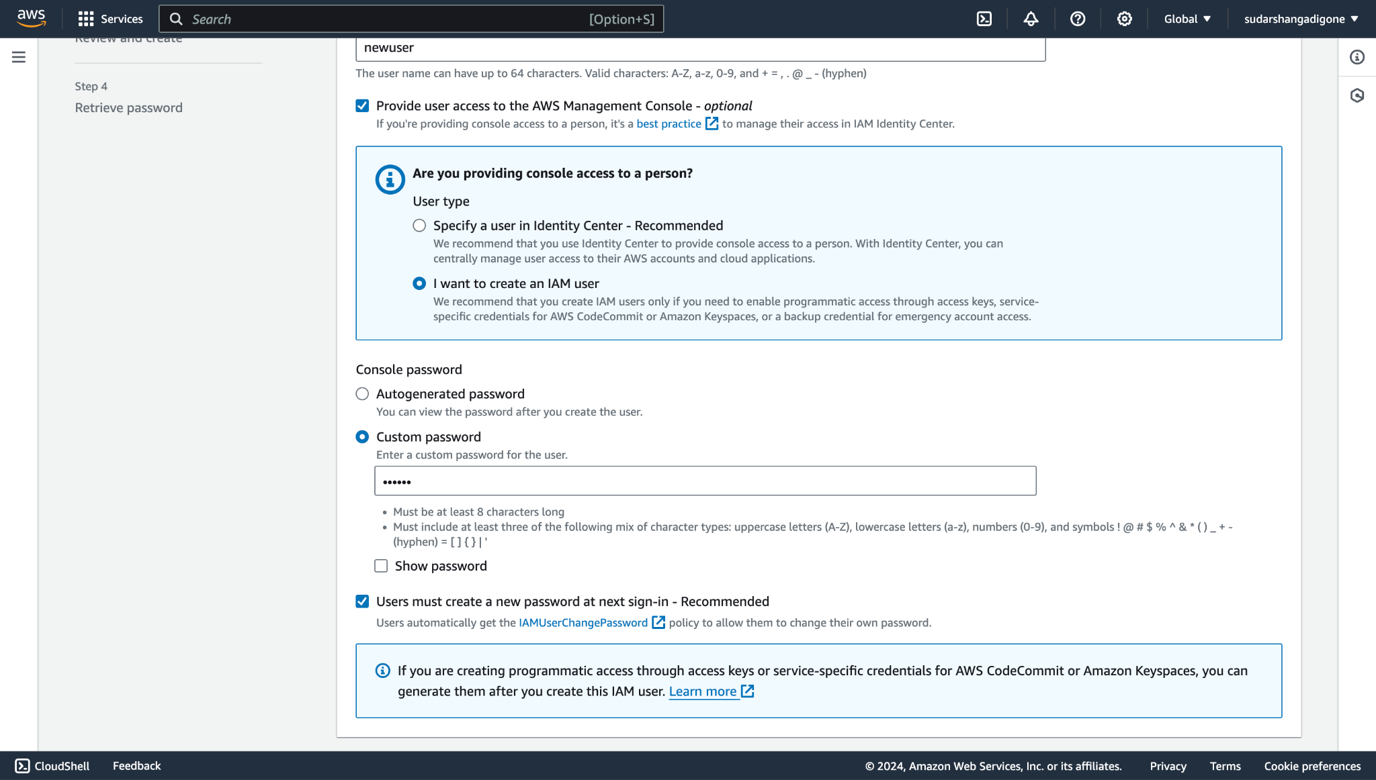

**Step 4.** Create a new group and name it say ycce1. Thus we have successfully created a group name ycce1. Then click next.

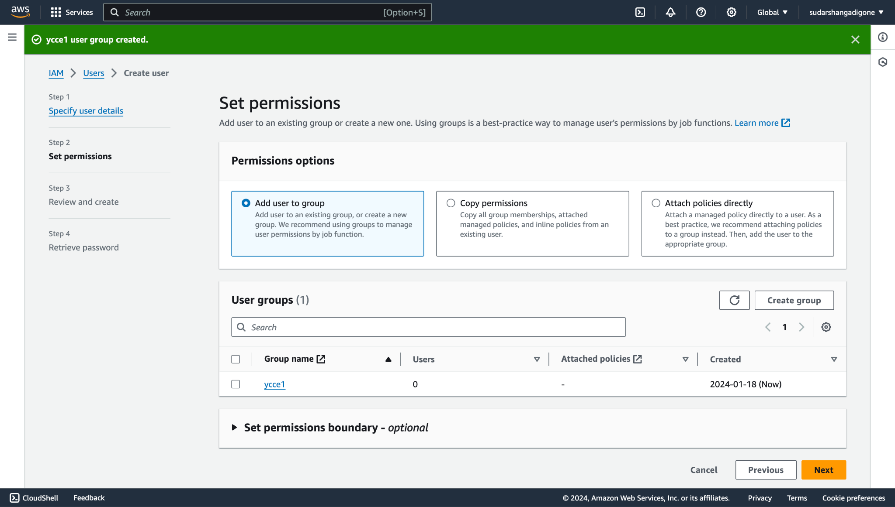

**Step 5. Now, click on Create user and thus we have successfully created a user.**

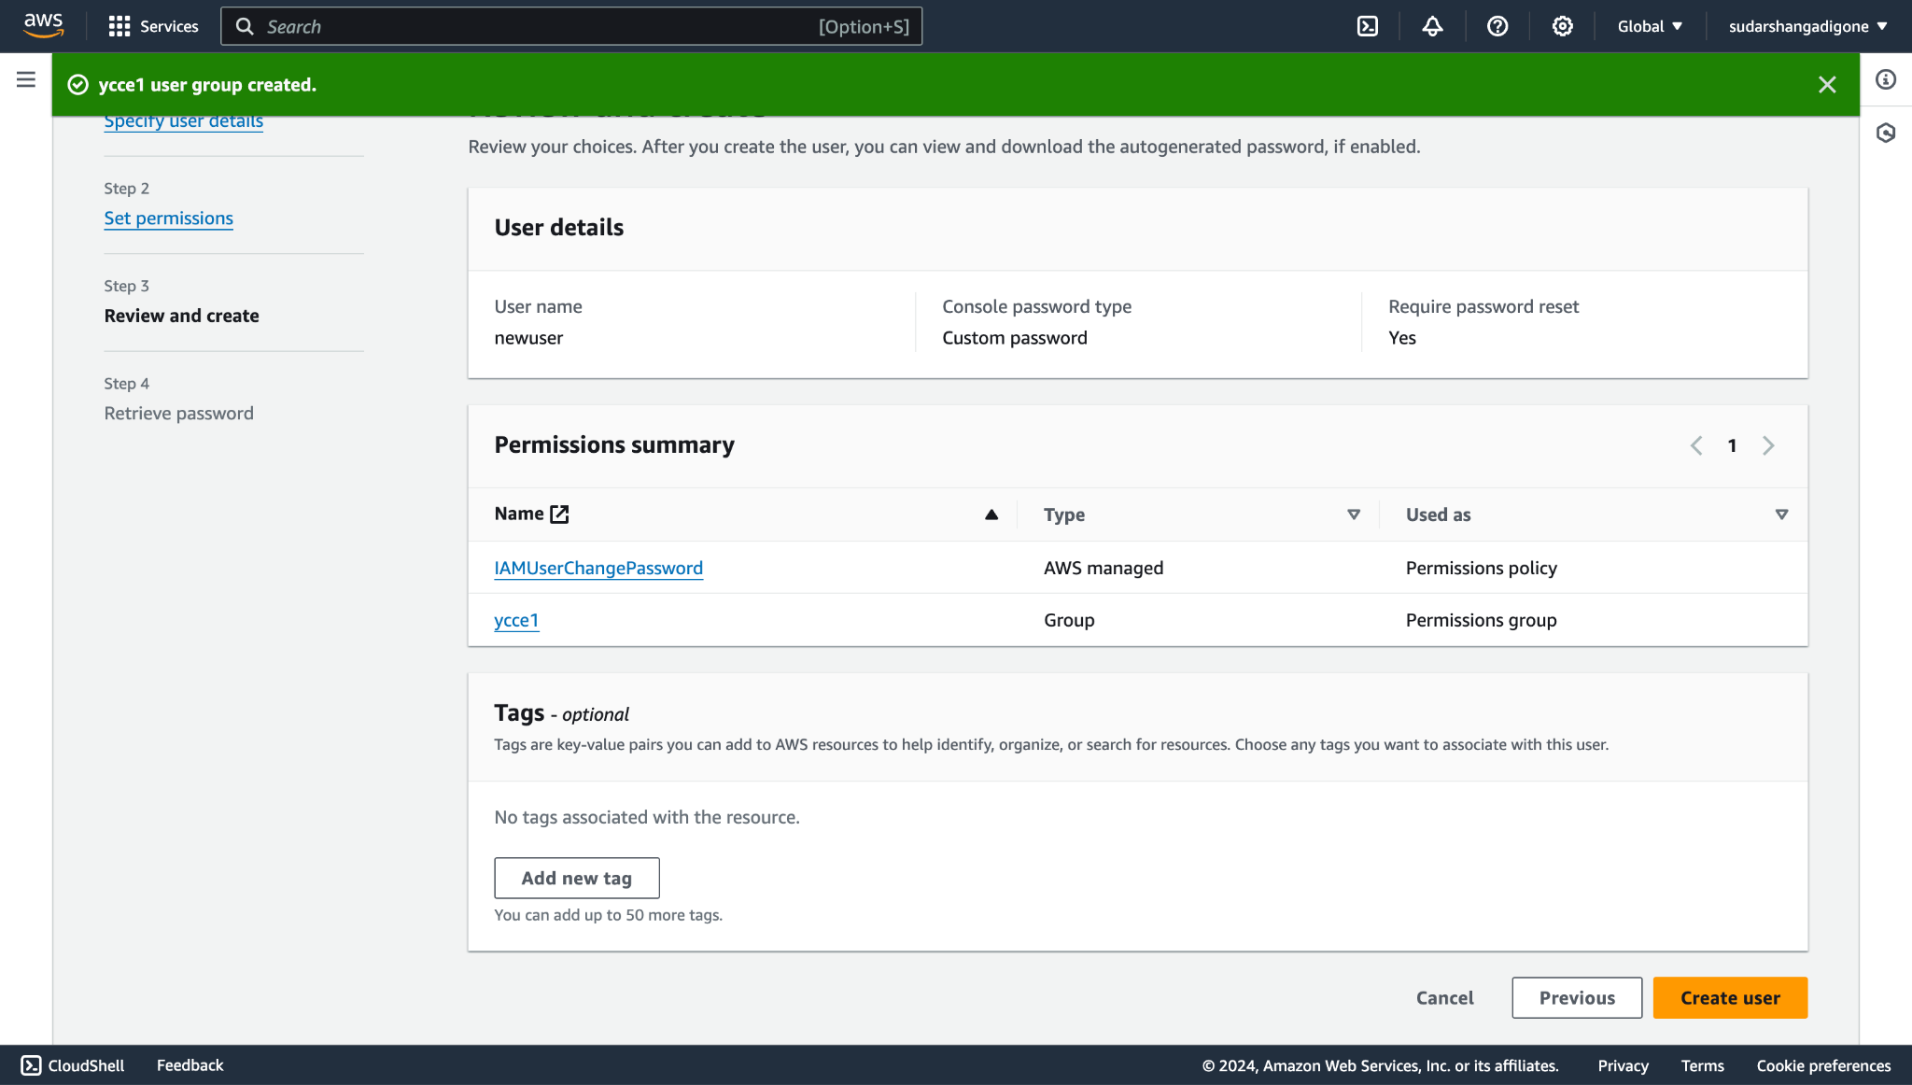

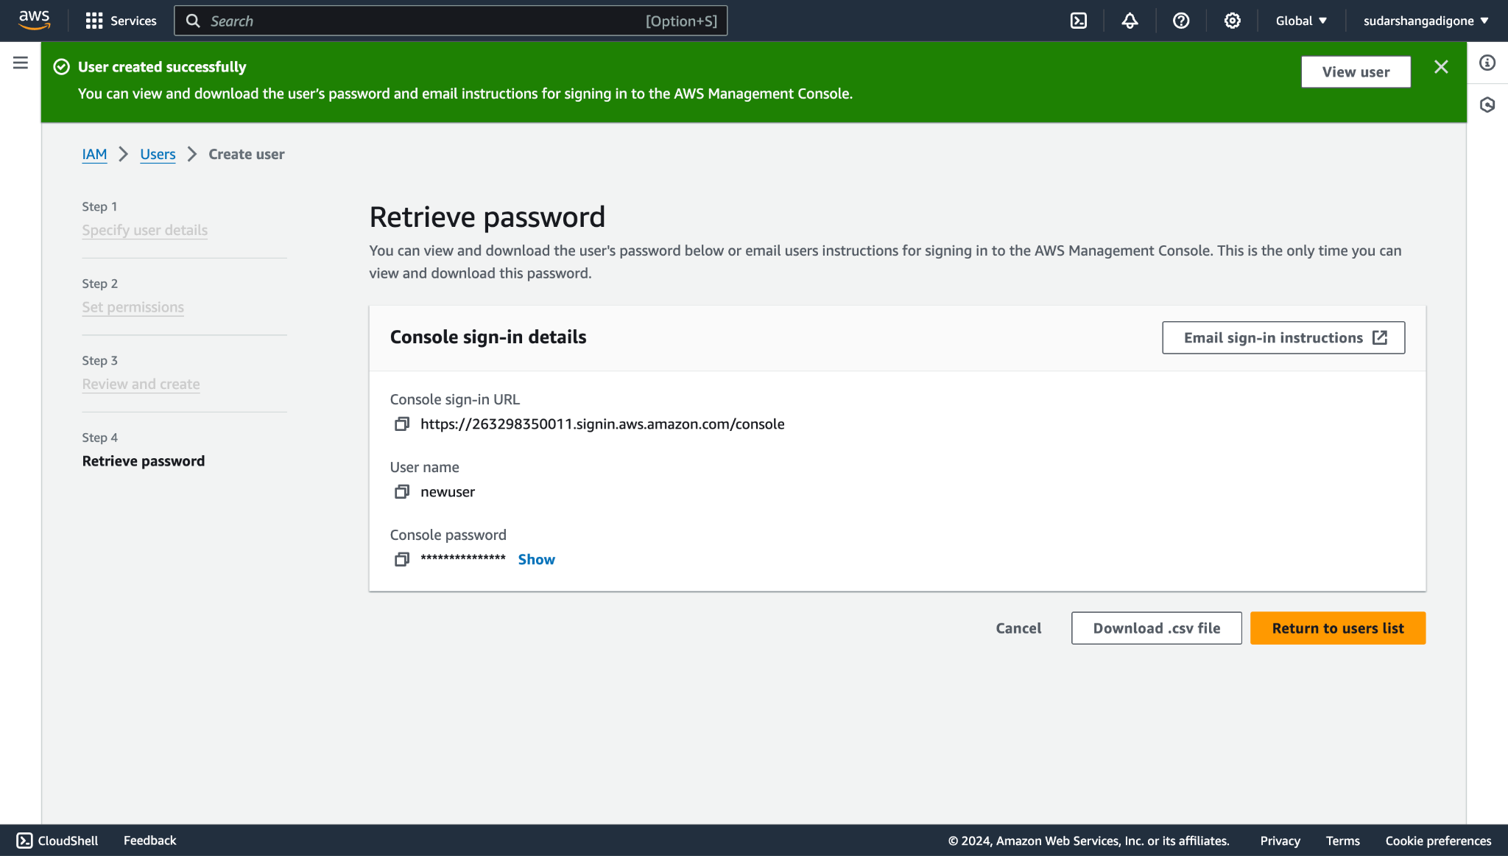

**Step 6.** Now click on the generated URL to get redirected to the AWS server CONSOLE. Then Input your username and password.

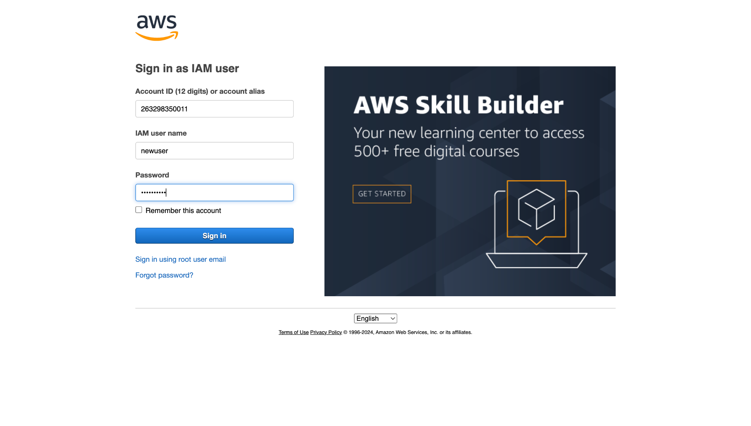

Hence, we have successfully logged in to the IAM user.

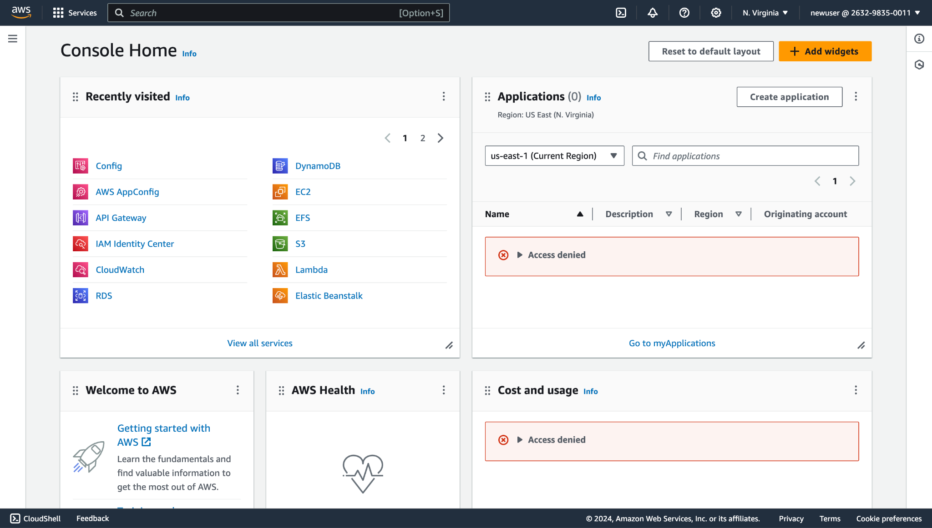

**CONCLUSION:**

Thus, we have successfully Demonstrated Usage of IAM on AWS console.